Interview Questions for
Merrick Rosenberg

Background
Title: CEO of Take Flight Learning

Author: The Chameleon: Life-Changing Wisdom for Anyone Who Has a Personality or Knows Someone Who Does. His book is available on Amazon.

Bio introduction: Merrick Rosenberg co-founded Team Builders Plus in 1991 and Take Flight Learning in 2012. He is the author of Personality Wins, The Chameleon and Taking Flight, three books about personality. Under Merrick’s leadership as CEO of Take Flight Learning, his company has been selected as the New Jersey Business of the Year and named one of the Fastest Growing Companies and Best Places to Work in the Philadelphia area. Merrick received his MBA from Drexel University who recognized him as the Alumni Entrepreneur of the Year. Merrick has worked with more than half of the Fortune 100 companies in the US and around the world.
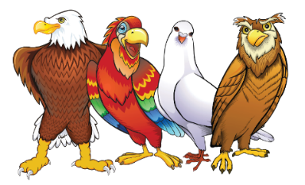
Websites: MerrickRosenberg.com, TakeFlightLearning.com
Twitter: @MerrickR
Instagram: Merrick_Rosenberg
Facebook: https://www.facebook.com/PersonalityWins
LinkedIn: https://www.linkedin.com/in/merrickrosenberg/
YouTube: http://www.youtube.com/c/TakeflightlearningDISCProducts
Facebook: https://facebook.com.personalitywins/
Merrick’s book, The Chameleon: http://bit.ly/TheChameleon-Amazon

Introduction to the styles:
- Tell me about the four personality styles? (Eagles are direct and results driven; Parrots are social and enthusiastic; Doves are harmonious and compassionate; Owls are logical and detail-oriented)
- Why birds did you select birds to represent the personality styles?

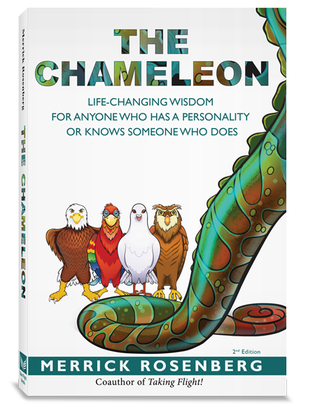
Merrick Rosenberg:
- When did you start working with personalities?
- What made you decide to start this career path?
- How did you learn about the personality styles?

Take Flight Learning:
- What does your company do?
- Do you run training programs just for managers or is this something everyone should learn?

The Chameleon (book):
- Why did you write the book?
- Who is the ideal reader for this book?
- Would you mind sharing one of the fables with us?

General questions:
- Are people a combination of the four styles?
- People are complicated, how can you simplify it down to just four styles?
- Are we born this way or does our environment determine our DISC style?
- How do I get someone to flex to my style?
- How can you tell a person’s style if you’ve just met them?
- Can you determine someone’s style by how they write an email?
- Is any style more likely to be a morning person?
- How can you tell somebody’s style over the phone?
- Do styles change over the years?
- Can we change our personality style?
- Is flexing to someone else’s style manipulative?
- What would you say to people who are skeptical and say you can’t read them because they’re too complicated?

Sales
- Why is style important in a sales situation?
- How can someone’s personality style work against as a salesperson?
- It would seem that self-awareness plays a big role in tapping into the power of our personality styles. How important is it that a salesperson understands his or her personality?
- Do some people find certain aspects of their job difficult because of their style?
- Can you use the styles to sell better with fellow coworkers? For example, a salesperson and an engineer may step on each other’s toes in a sales call.
- How can you read a prospect’s style? Are their clues before you meet them face-to-face, such as their email correspondence or LinkedIn profile?
- How can you use the style to sell a companies with different cultures?

Leadership:
- Is one style a better leader than other styles? One would think that eagles are the best leaders.
- Are most Presidents of the United States eagles?
- Which style do people like to work for?
- Can you describe each type of leader?
- Can you give examples of a leader with each style?
- Leaders often have to communicate to a lot of people at once. Can you use the personality styles to be a better communicator?

Teams
- Should a team have people with all four styles?
- What happens when a team is missing one of the styles?
- What if a team has people who have the same style?
- What happens if you have a whole bunch of people with one style and one person of a different style?
- What happens when a leader has a different personality than the team members?
- Do some people prefer work alone than in teams?
- Do people sometimes have to flex their personality to a different situations?

Companies
- Do companies have a personality?
- How does personality impact corporate culture?
- Do people choose to work at certain companies because of their personality?

Business:
- Can a person have one style at work and a different style at home?
- Are people drawn to certain jobs because of the personality? For example, are all engineers Owls?
- Are people driven to specific careers because of their style?
- Can you tell somebody’s style based on their office or workspace?
- Should you look at style when hiring someone?
- Often when companies put people through training programs, they use their new skills for a while but then people fall back to their old behaviors. How do you make this learning stick?

Workplace Skills: How does each style…
- Communicate to others?
- Delegate work to staff members?
- Give feedback when people have performed well?
- Like to be rewarded and recognized for their contributions?
- Manage change?
- Handle stress in this stressful world?
- Deal with conflict?
- Manage their time or deal with their work?

The Golden Rule vs. The Home Rule
- In your books, you wrote about the Home Rule, which is “Treat others how they need to be treated not how you need to be treated?” It sounds like this is the opposite of the Golden Rule? Are you saying the Golden Rule of treating others how you want to be treated doesn’t work?
- How does understanding the Home rule vs. the Golden rule impact relationships?

Relationships:
- Do most spouses have different styles or the same?
- They say opposites attract. Is that true when it comes to personality style? Wouldn’t that just make people fight?
- Is it hard when people are married to someone who is so different?
- How can understanding the styles transform your relationship?
- Can you share stories of how understanding the personality styles has helped people’s relationships?
- Can you use the styles during dating?
- Would this work for marriage counseling?
- When people drive us crazy, do you think that related to personality styles?

Parenting:
- Why do parents need to know their kid's style?
- Do parents need to understand their own style to be better parents?
- Can a parent change their child’s personality?
- What if a parent’s style is different from their kids? It seems like that would make it hard on the parent.
- Can I use DISC to get my kid to be more outgoing? He’s so shy.
- It would seem that children should learn this in school. Are kids being taught the styles?

